Firstable we have to open our software of virtualization, in our case is VirtualBox:

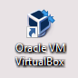

Then when we opened the application we are going to click in this icon:



In this window we have to put name for the OS, the machine folder, the type of de OS and the version of this one:

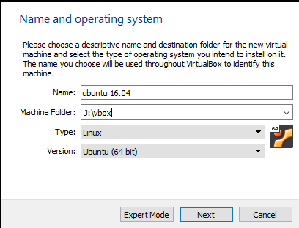

Then we have to select the amount of memory that we want to use:

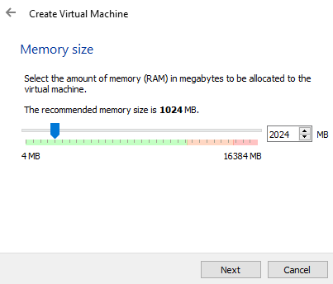

Now we are going to choose if we want to use a new disk or we want use a already created disk

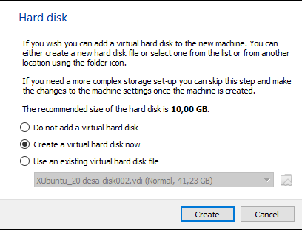

Next we are going to select the type of hard disk file:

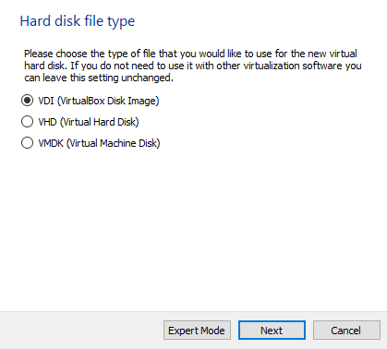

Now have to choose if we want a dynamic o fixed size

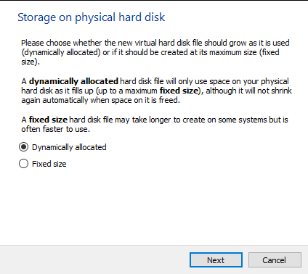

Then we are going to select the size of the disk

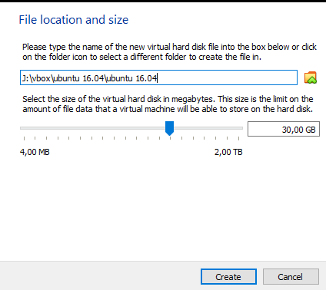

Now we have to put the iso image in the storage Settings:

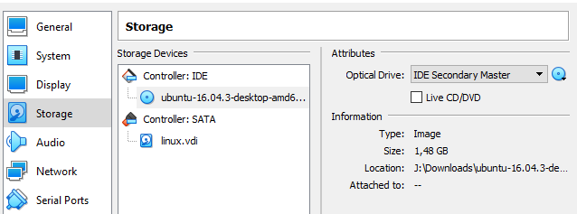

We select the Ubuntu iso and then press ok button,

Now we proceed with the installation of ubuntu

In this menu we click in the install Ubuntu option:

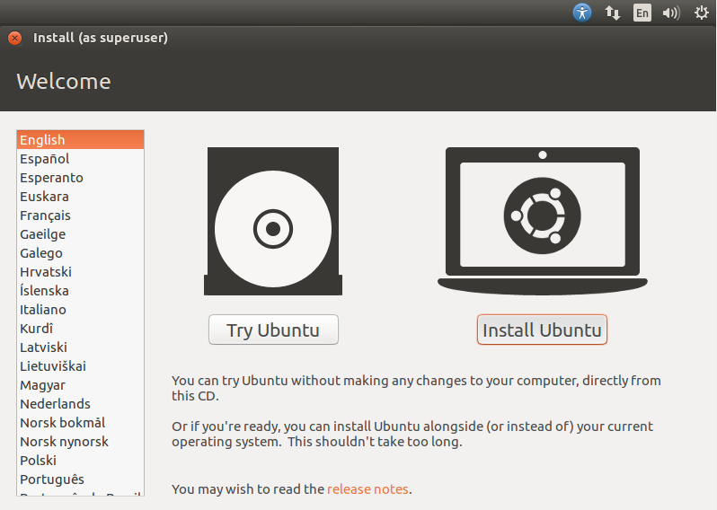

Then we have to check the following option:

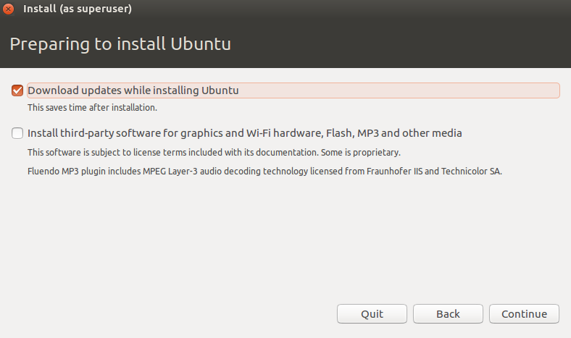

And now select the “Something else” option to modify the particions:

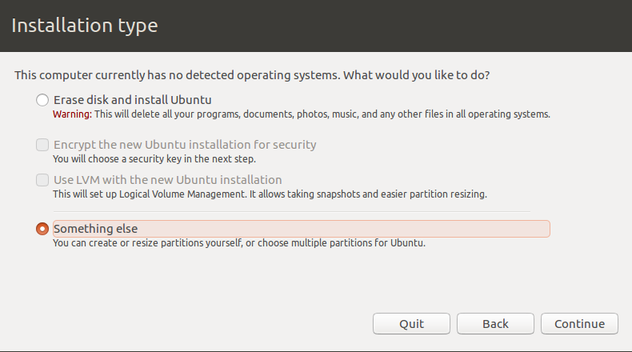

and press continue:

Now we have to create a “New partition Table..”: and press continue:

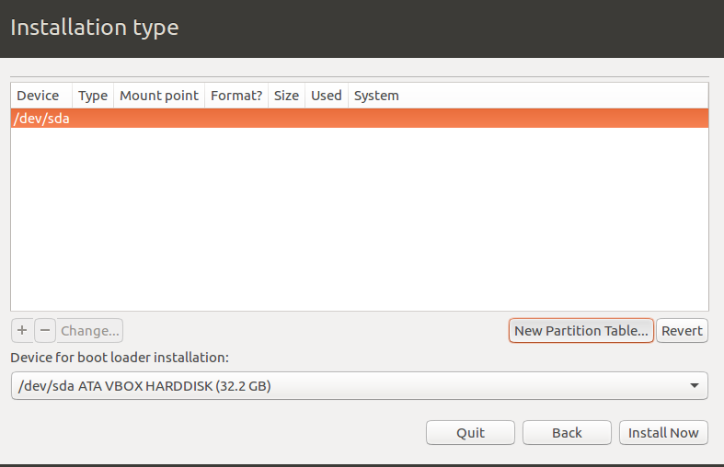

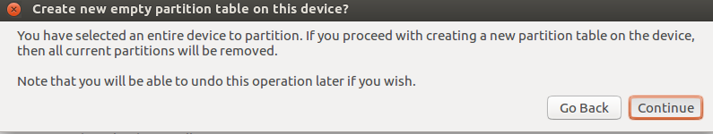

Now we are going to create the first partition, we have to create the /boot

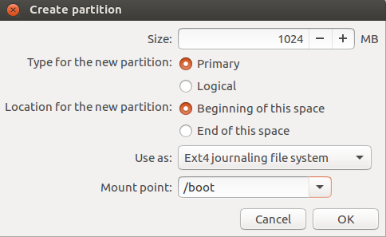

Then we have to create the second partition it will be the swap area:

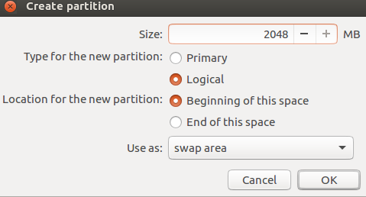

Now the third partition “/”:

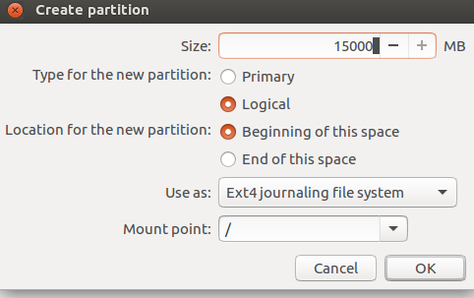

Then the last partition must be /home: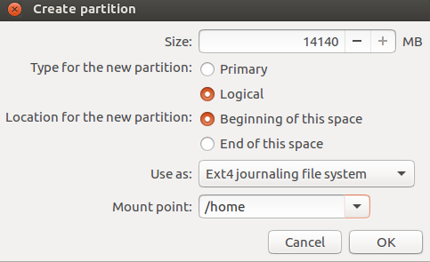

Now we click in install now:

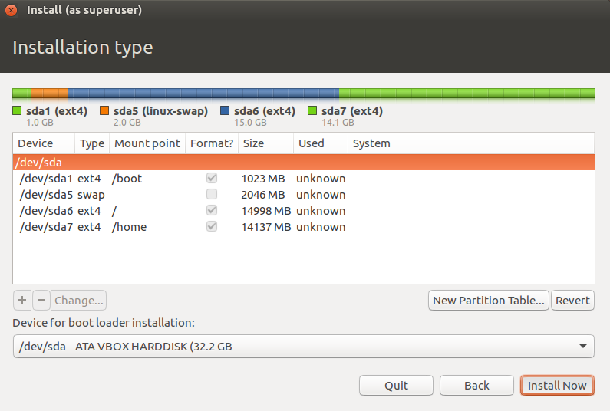

Now we are going to configure the following options, our keyboard’s layout and configure our user and password:

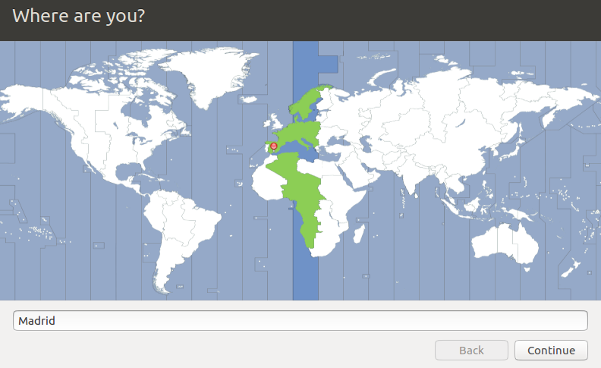

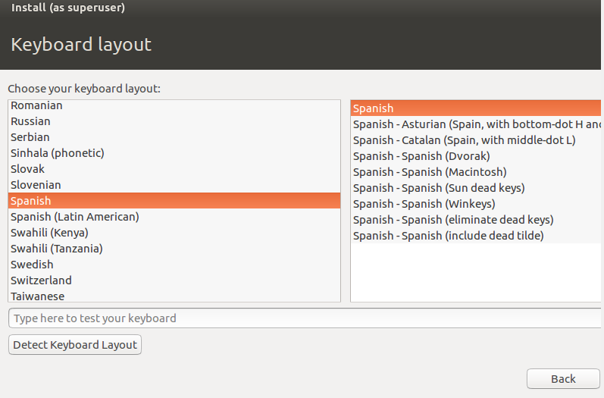

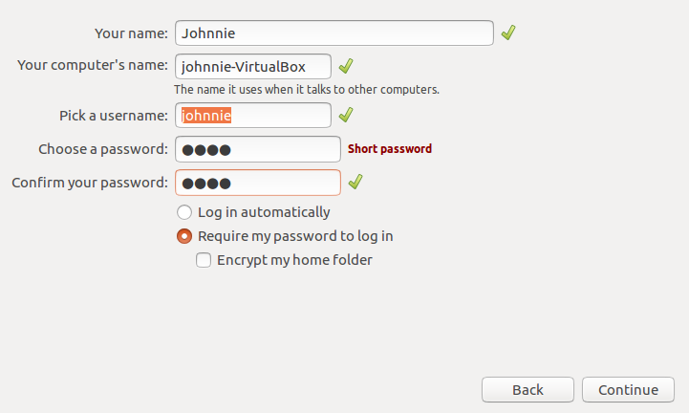

Now we have to wait until the installation will complete then restart the OS and that's all.

Now we have to share folder, for that we have go to settings and here we have to click in the shared folder option:



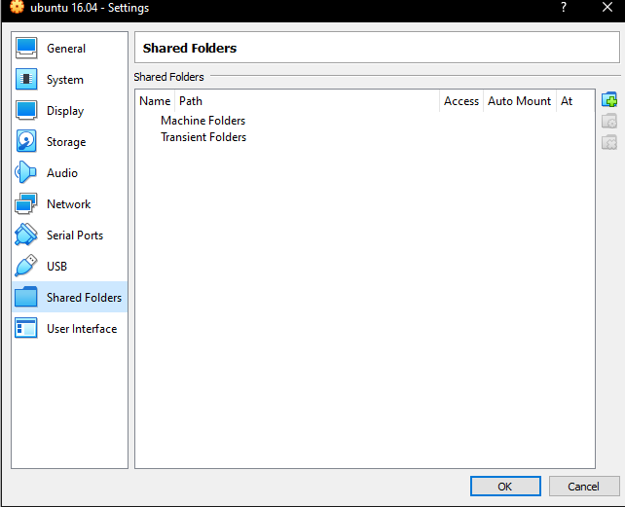

Here we click in this icon for add a folder to share:



Then the window open we have to put the followings options:

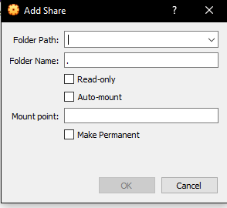

In folder path we have to select the path of the folder that we want to share

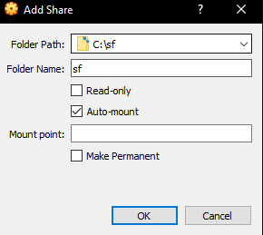

Next click the ok button and we will see this:

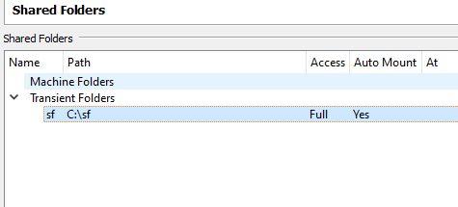

home 11 root 13 boot swap 2

Important: if u want see the share folder and you can't. You just have to put this command



Now we have to configure the internet connection:

For this we have to go to the network option in settings.

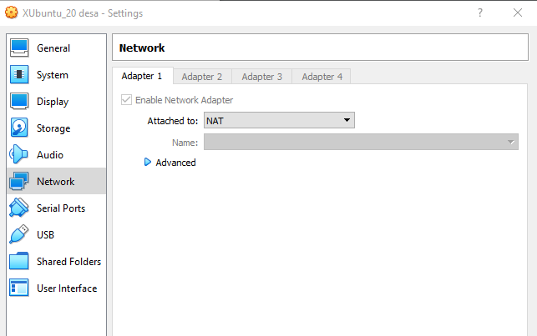

Then in “attached to”: we select the option called NAT “Bridget adapter” :

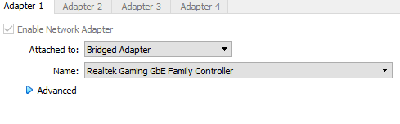

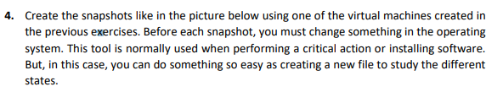

We are in the actual state

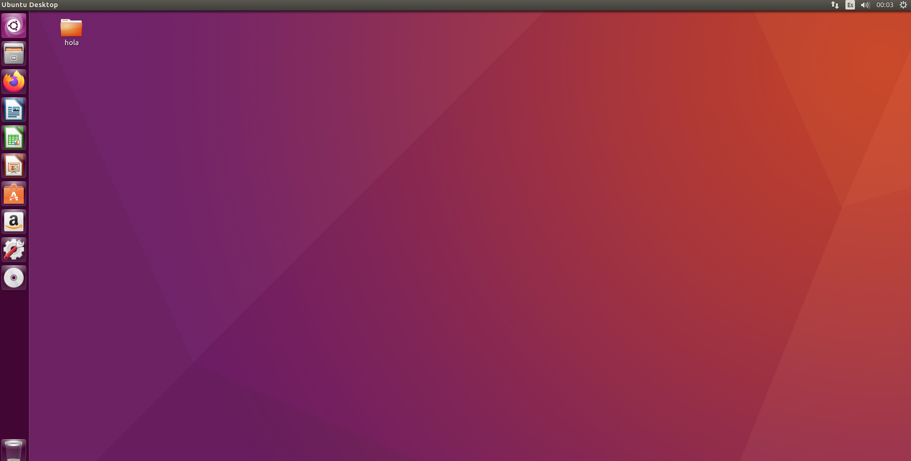

Now we have to take a snapshot

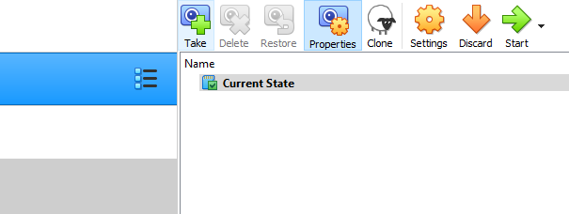

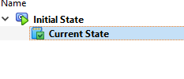

Then we have to create the State 2 modifying something for check in the following steps:

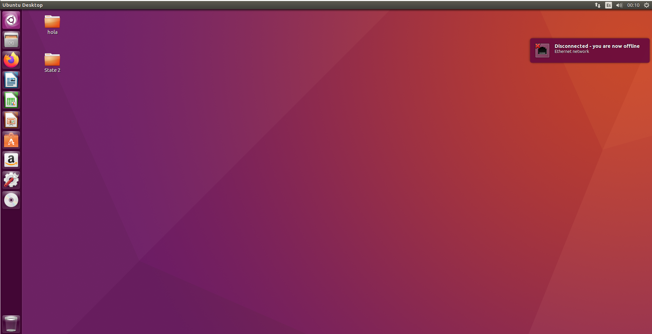

Let's take the snapshot State 2:

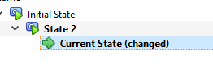

Now we are going to delete the folder that we create in the before step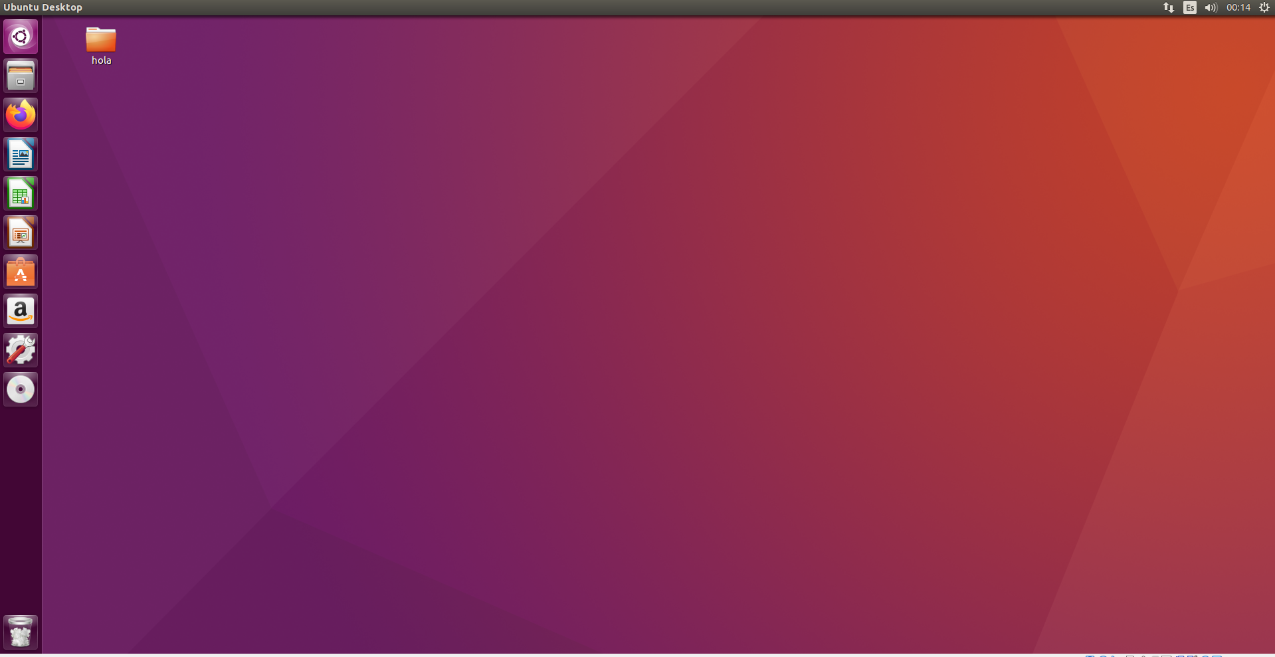

Now to do the State 2.1 we have to restore in the State 2:

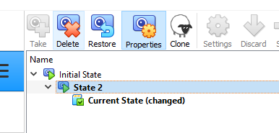

and this should looks like this:

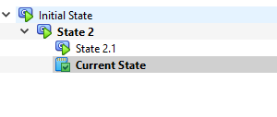

And you can see that we recover the folder that has been eliminated in the before steep:

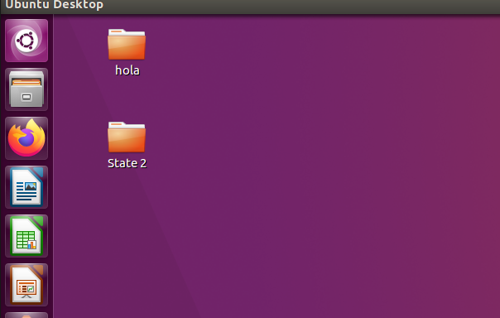

Next we are going to create again another snapshot with the name State 2.2:

